IoT Assignment-17

(Dheeraj Tiwari)

1.Write a coding in HTML to create a page with Largest heading and a paragraph with a green background color of a page.

Code :

<!DOCTYPE html>

<html lang="en">

<head>

    <meta charset="UTF-8">

    <meta name="viewport" content="width=device-width, initial-scale=1.0">

    <title>heading</title>

</head>

<body>

    <h1 style="textalign:center;color:rgba(143, 3, 3, 0.678);">IoT course</h1>

    <p style="background-color:rgb(81, 175, 37);">

        Lorem ipsum dolor sit amet consectetur, adipisicing elit. Nemo, molestias! Veniam, possimus deserunt! Debitis a cupiditate repudiandae voluptate non expedita laborum adipisci similique? Doloremque voluptas asperiores ipsa ipsam nostrum, ex quasi delectus, doloribus eum molestias nam! Et odit illo dicta tempore libero aperiam ut reiciendis molestiae cumque quis numquam necessitatibus accusantium mollitia, tenetur reprehenderit hic modi voluptate quidem aspernatur perferendis impedit nobis possimus. Nihil magni est quos incidunt, ea quidem iste blanditiis? Delectus pariatur possimus amet accusamus deserunt tempore aliquam atque quod commodi asperiores vero praesentium voluptatum natus totam illum dolorem, illo, consequuntur magnam. Asperiores dolorem corporis ratione voluptates impedit.

    </p>

</body>

</html>

1. Write a coding in HTML to create a link on the above page which access to the Wikipedia of PM Narendra modi.

Ans : <!DOCTYPE html>

<html lang="en">

<head>

    <meta charset="UTF-8">

    <meta name="viewport" content="width=device-width, initial-scale=1.0">

    <title>heading</title>

</head>

<body>

    <h1 style="textalign:center;color:rgba(143, 3, 3, 0.678);">Wikipedia of PM Narendra modi</h1>

    <p style="background-color:rgb(238, 221, 188);">

        URL for Wikipedia:<a href="https://en.wikipedia.org/wiki/Narendra_Modi"target="_blank">Narendra Modi</a>

    </p>

</body>

</html>

1. Create a time table of a college schedule using Tables and its attributes in HTML?

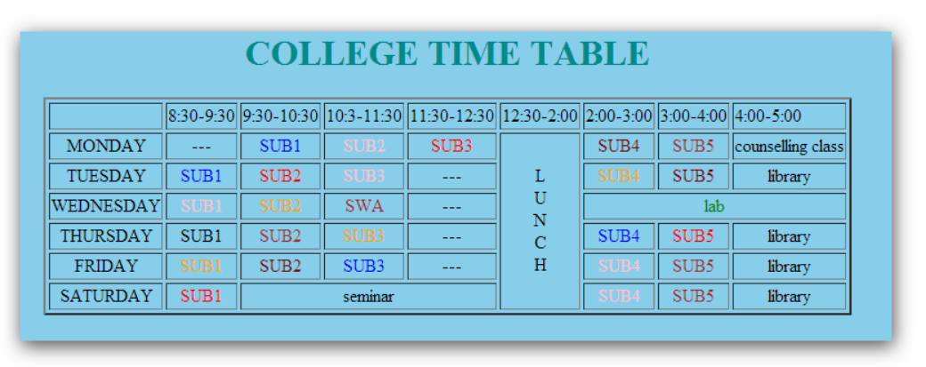

Ans: <!DOCTYPE html>

<html>

<body style="background-color: rgba(46, 188, 245, 0.548);">

  <h1 align="center" height="50" style="color: green;">COLLEGE TIME TABLE</h1>

    <table border="5" cellspacing="0" align="center">

        <!--<caption>Timetable</caption>-->

        <tr>

            <td align="center" height="50" width="100"><br>

                <b>Day/Period</b></br>

            </td>

            <td align="center" height="50" width="100">

                <b>I<br>9:30-10:20</b>

            </td>

            <td align="center" height="50" width="100">

                <b>II<br>10:20-11:10</b>

            </td>

            <td align="center" height="50" width="100">

                <b>III<br>11:10-12:00</b>

            </td>

            <td align="center" height="50" width="100">

                <b>12:00-12:40</b>

            </td>

            <td align="center" height="50" width="100">

                <b>IV<br>12:40-1:30</b>

            </td>

            <td align="center" height="50" width="100">

                <b>V<br>1:30-2:20</b>

            </td>

            <td align="center" height="50" width="100">

                <b>VI<br>2:20-3:10</b>

            </td>

            <td align="center" height="50" width="100">

                <b>VII<br>3:10-4:00</b>

            </td>

        </tr>

        <tr>

            <td align="center" height="50">

                <b>Monday</b></td>

            <td align="center" height="50">----</td>

            <td align="center" height="50">SUB1</td>

            <td align="center" height="50">SUB2</td>

            <td rowspan="6" align="center" height="50">

                <h2>L<br>U<br>N<br>C<br>H</h2>

            <td align="center" height="50">SUB3</td>

            <td align="center" height="50">SUB4</td>

            <td align="center" height="50">SUB5</td>

            <td align="center" height="50">Counselling Class</td>

            </td>

        </tr>

        <tr>

            <td align="center" height="50">

                <b>Tuesday</b>

            </td>

            <td align="center" height="50">SUB1</td>

            <td align="center" height="50">SUB2</td>

            <td align="center" height="50">---</td>

            <td align="center" height="50">SUB3</td>

            <td align="center" height="50">SUB4</td>

            <td align="center" height="50">SUB5</td>

            <td align="center" height="50">LIBRARY</td>

        </tr>

        <tr>

            <td align="center" height="50">

                <b>Wednesday</b>

            </td>

            <td align="center" height="50">SUB1</td>

            <td align="center" height="50">SUB2</td>

            <td align="center" height="50">---</td>

            <td colspan="4" align="center" height="50">LAB

            </td>

        </tr>

        <tr>

            <td align="center" height="50">

                <b>Thursday</b>

            </td>

            <td align="center" height="50">SUB1</td>

            <td align="center" height="50">SUB2</td>

            <td align="center" height="50">---</td>

            <td align="center" height="50">SUB3</td>

            <td align="center" height="50">SUB4</td>

            <td align="center" height="50">SUB5</td>

            <td align="center" height="50">LIBRARY</td>

        </tr>

        <tr>

            <td align="center" height="50">

                <b>Friday</b>

            </td>

            <td align="center" height="50">SUB1</td>

            <td align="center" height="50">SUB2</td>

            <td align="center" height="50">---</td>

            <td align="center" height="50">SUB3</td>

            <td align="center" height="50">SUB4</td>

            <td align="center" height="50">SUB5</td>

            <td align="center" height="50">LIBRARY</td>

        </tr>

        <tr>

            <td align="center" height="50">

                <b>Saturday</b>

            </td>

            <td align="center" height="50">SUB1</td>

            <td colspan="2" align="center" height="50">SEMINAR</td>

            <td align="center" height="50">SUB3</td>

            <td align="center" height="50">SUB4</td>

            <td align="center" height="50">SUB5</td>

            <td align="center" height="50">LIBRARY</td>

        </tr>

    </table>

</body>

</html>